# Practical 10: Create a Labeling Job

Step 1: Open S3

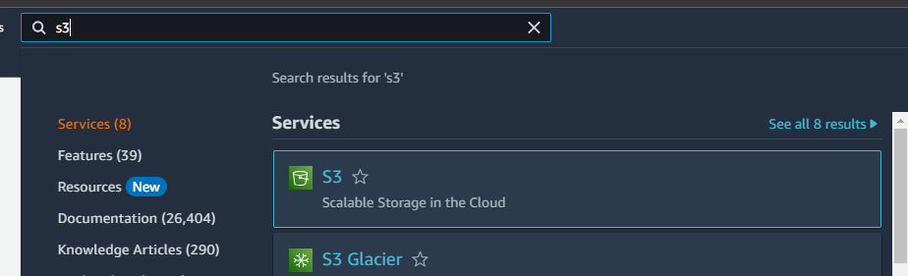

Step 2: Create a bucket

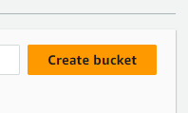

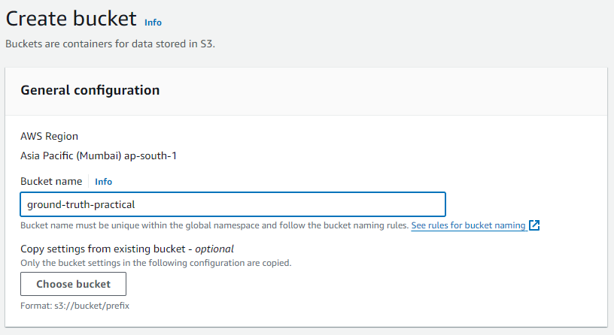

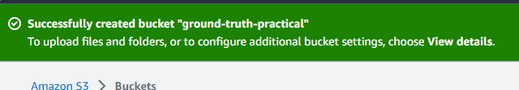

Step 3: Save two images at publicly available HTTP URLs. The images are used when creating instructions for completing a labeling task. The images should have an aspect ratio of around 2:1. For this exercise, the content of the images is not important.

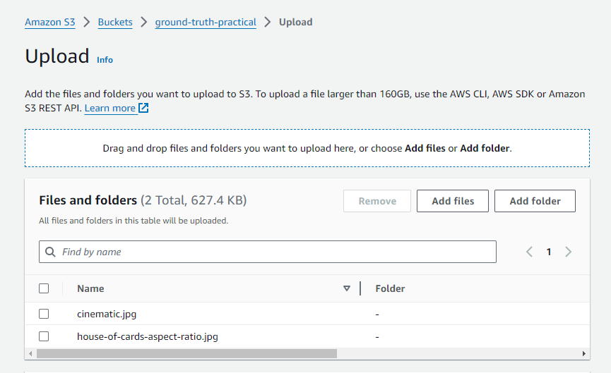

Step 4: Successfully updated

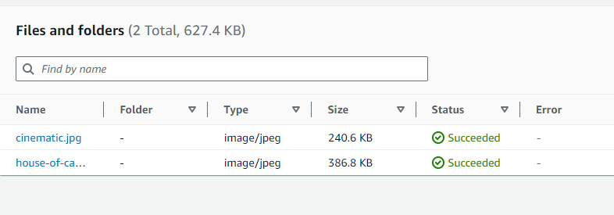

Step 5: Open the SageMaker console

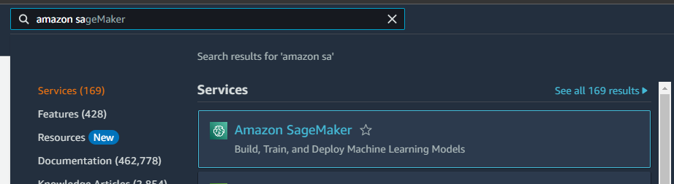

Step 6: From the left navigation, choose **Labeling workforces**

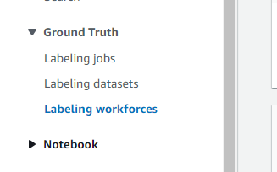

Step 7: create a private team

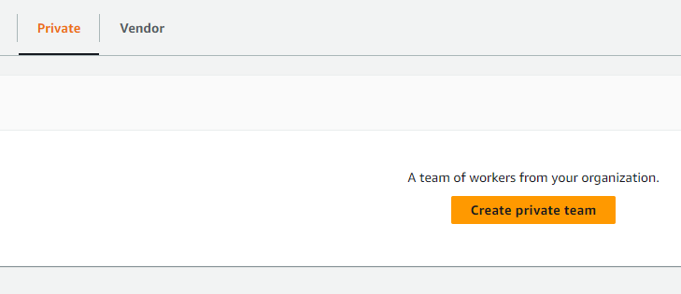

Step 8: Enter a name and description for your team. Add email , organization name

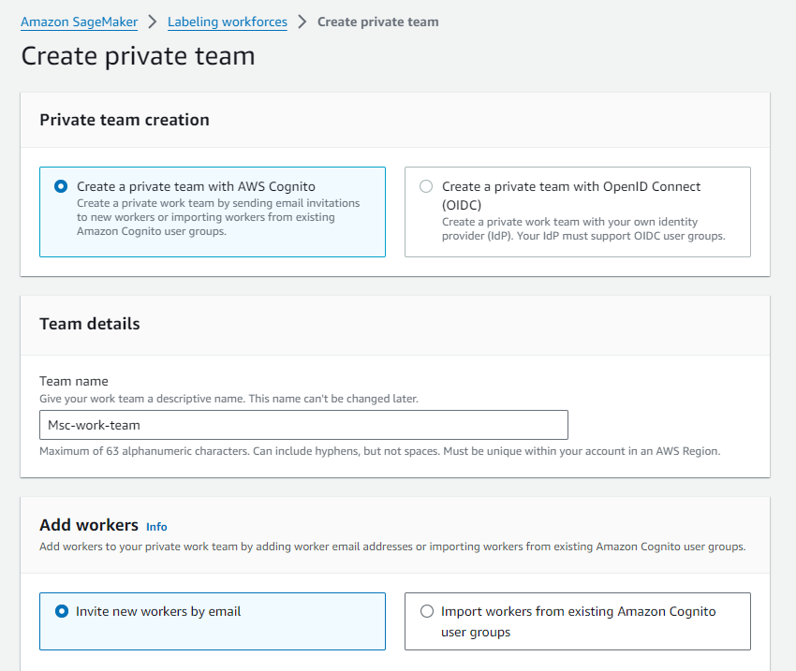

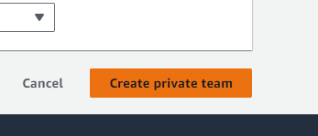

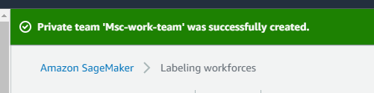

Step 9: Add workers

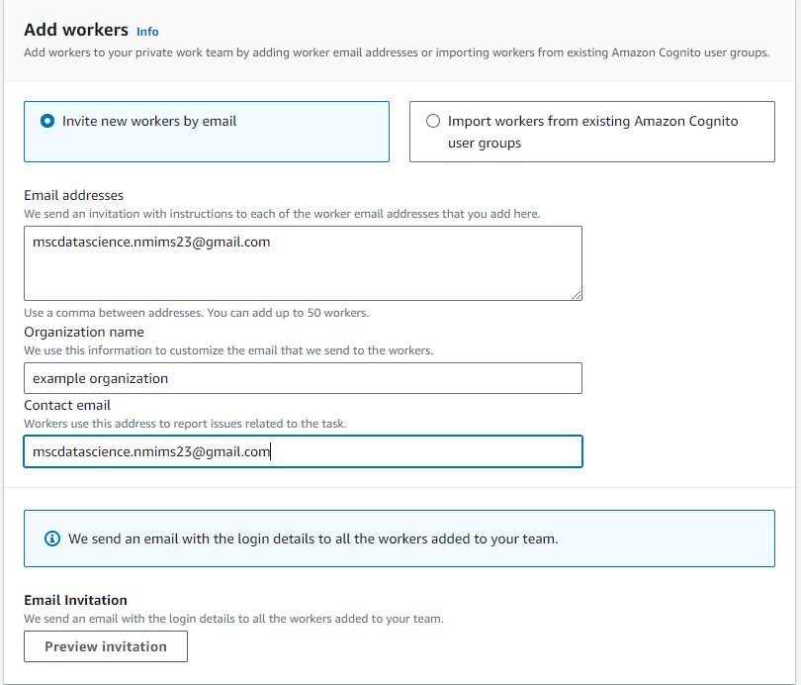

Step 10: Open the SageMaker console

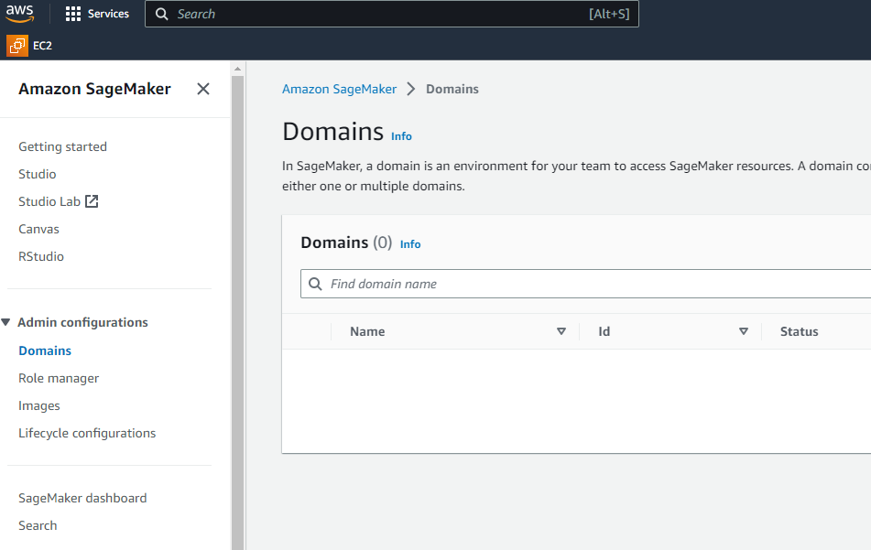

Step 11: From the left navigation, choose **Labeling jobs**

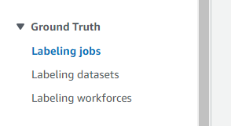

Step 12: Choose **Create labeling job** to start the job creation process

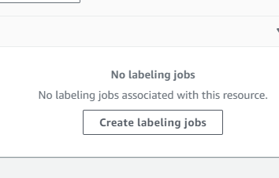

Step 13: **Job name** – Give the labeling job a name that describes the job. This name is shown in your job list. The name must be unique in your account in an AWS Region.

**Input data setup** – Select Automated data setup. This option allows you to automatically connect to your input data in S3.

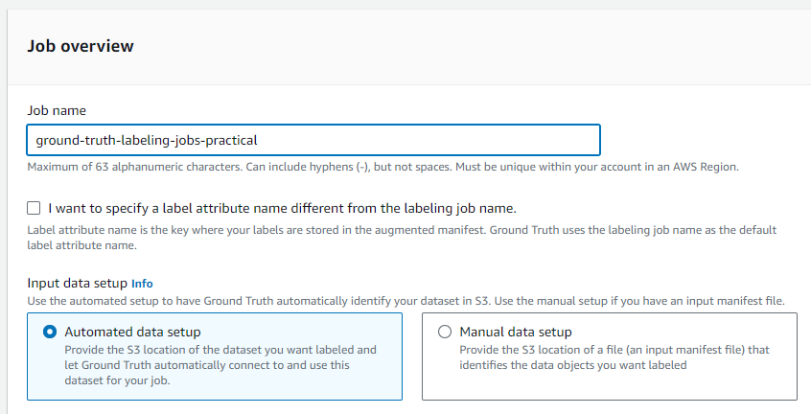

Step 14: Browse any S3 bucket

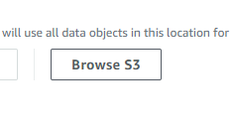

Step 15: Locate the bucket

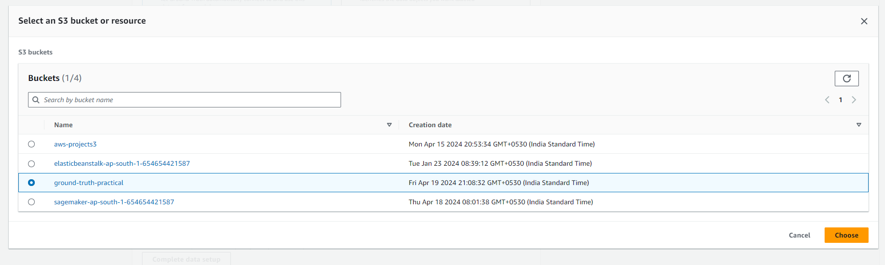

Step 16: S3 location for input datasets – Enter the S3 location where you added the images in step 1.

**Data type** – Use the drop down menu to **select Image**. Ground Truth will use all images found in the S3 location for input datasets as input for your labeling job.

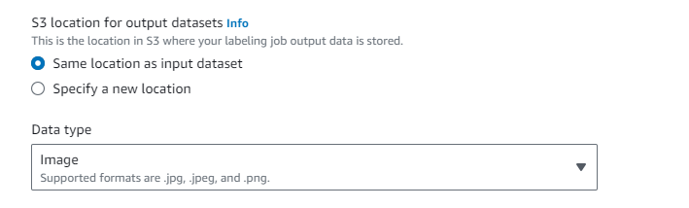

Step 17: **IAM role** – Create or choose an IAM role with the AmazonSageMakerFullAccess IAM policy attached.

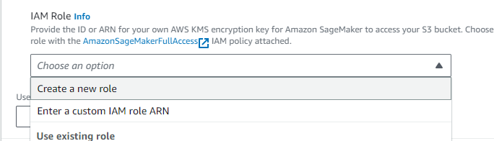

Step 18: Select any S3 bucket

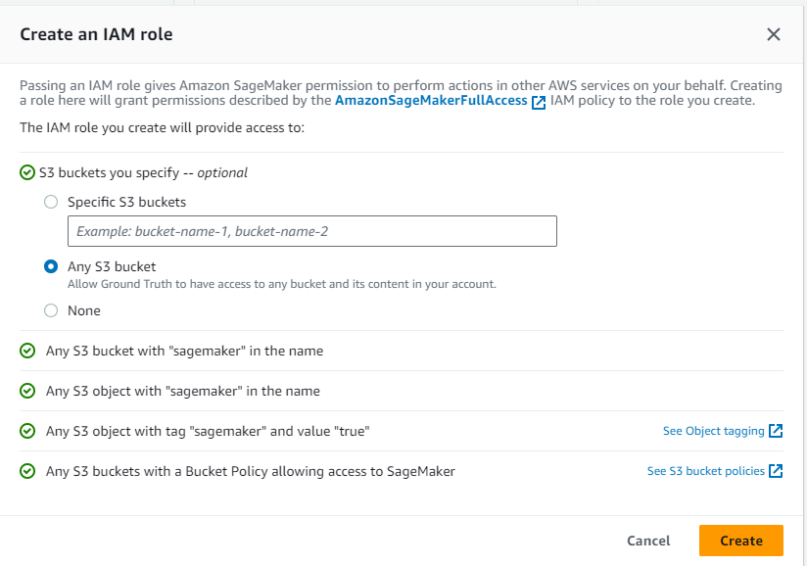

Step 19: Click Complete data setup

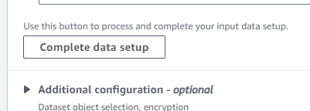

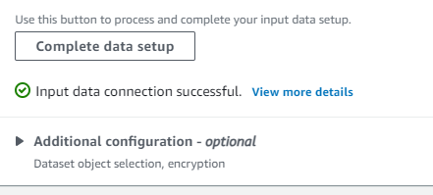

Step 20: Select Image and Bounding Box

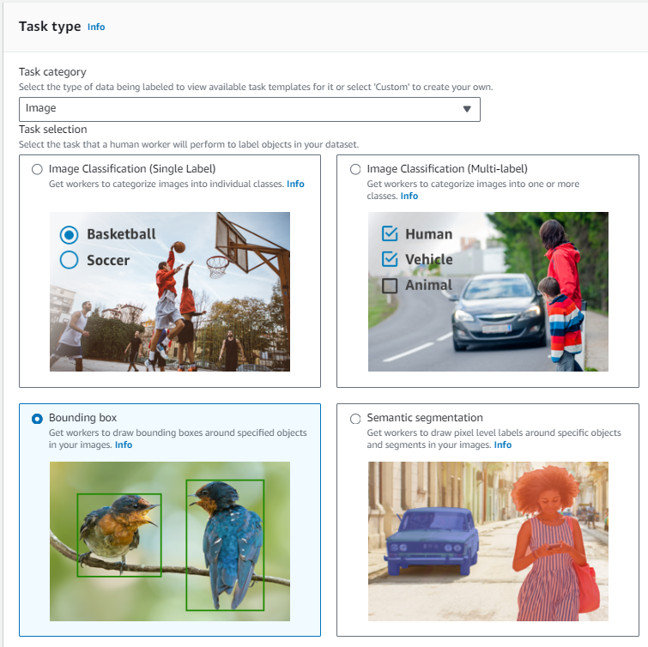

Step 21: Click Next

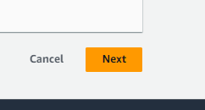

Step 22: In the Workers section, choose Private. Give team name

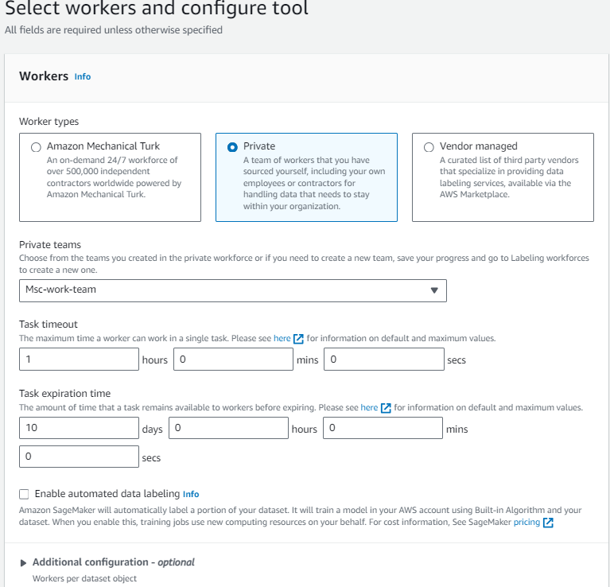

Step 23: configure the bounding box tool

After you have configured and verified your instructions, select Create to create the labeling job.

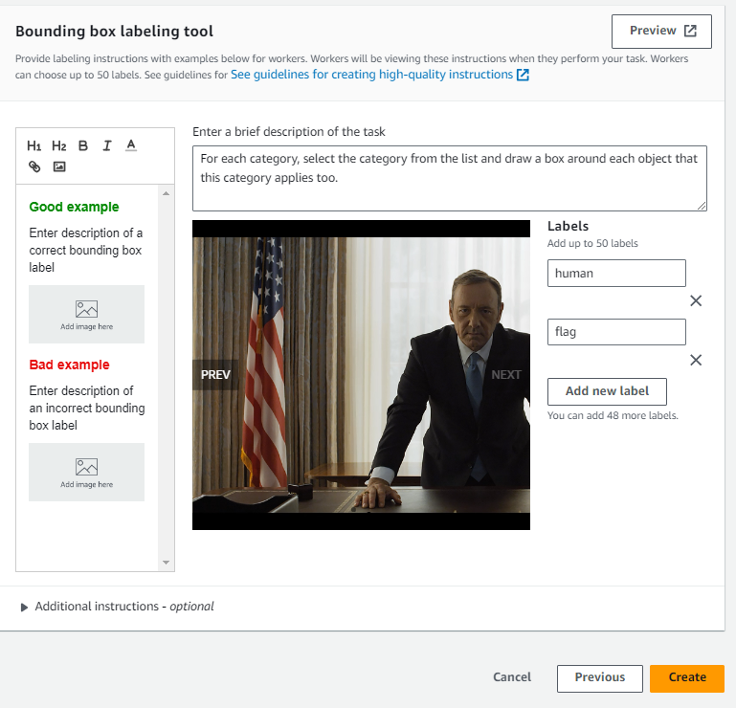

Step 24: Monitoring Your Labeling Job

